**NIT3222 – Virtualisation in Computing**

**Lab 4**

***ID: s4650134 Name: _Sen Fang_________***

In this lab we will make use of two types of virtual networks available in Hyper-V: Internal and Private. Refer to the lecture notes or the book to determine which network configuration is needed for the given scenarios.

You create virtual networks using the Virtual Network Manager (name the network after each scenario). After creation you need to connect the VM’s virtual adapter to the virtual network. Also note you will have to assign IP addresses to the interfaces to enable correct communication between the virtual machines. You should use the 192.168.0.0/24 address space to configure the network interfaces.

1. Scenario 1

In this scenario, only the virtual machines can communicate with each other. Create the network configuration according to the following figure.

Parent

Child

Child

Host

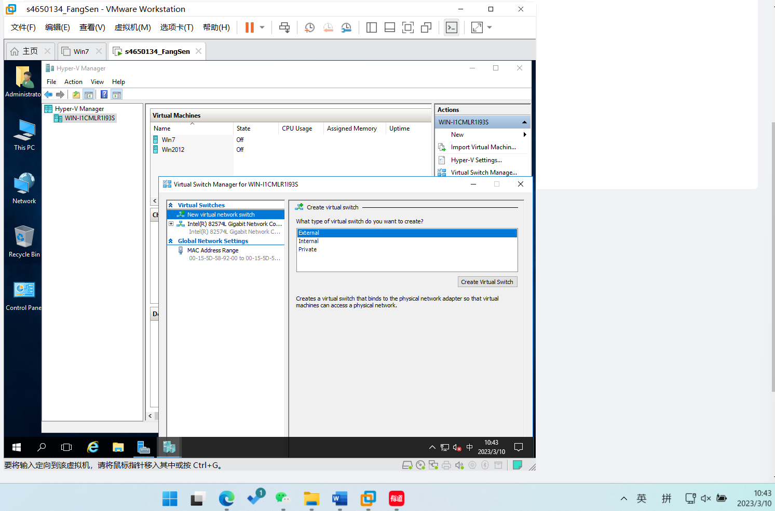

Figure

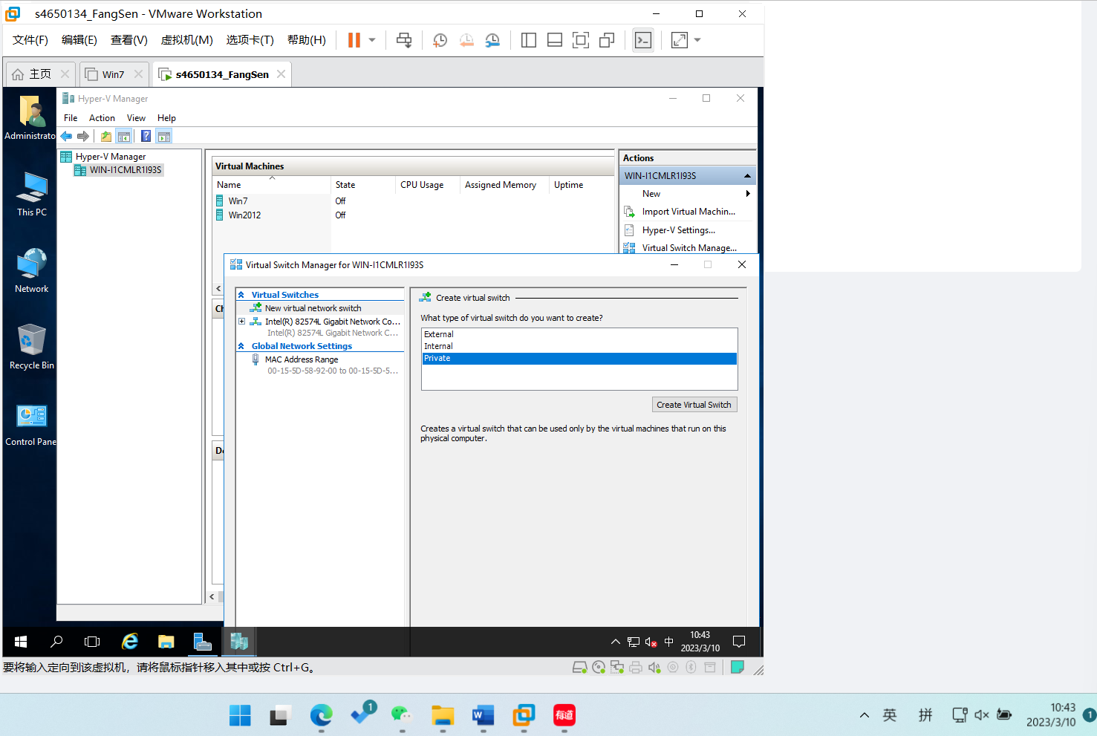

Figure

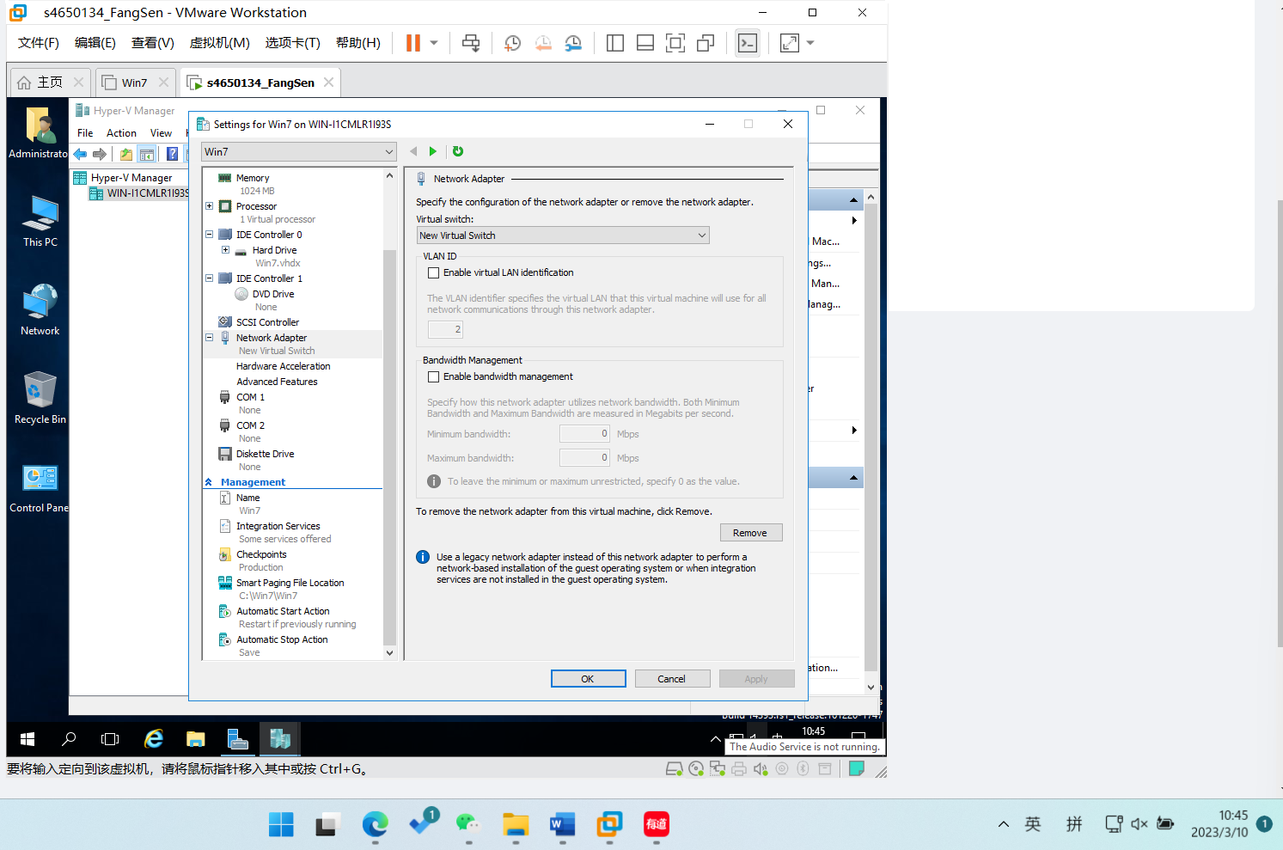

Figure

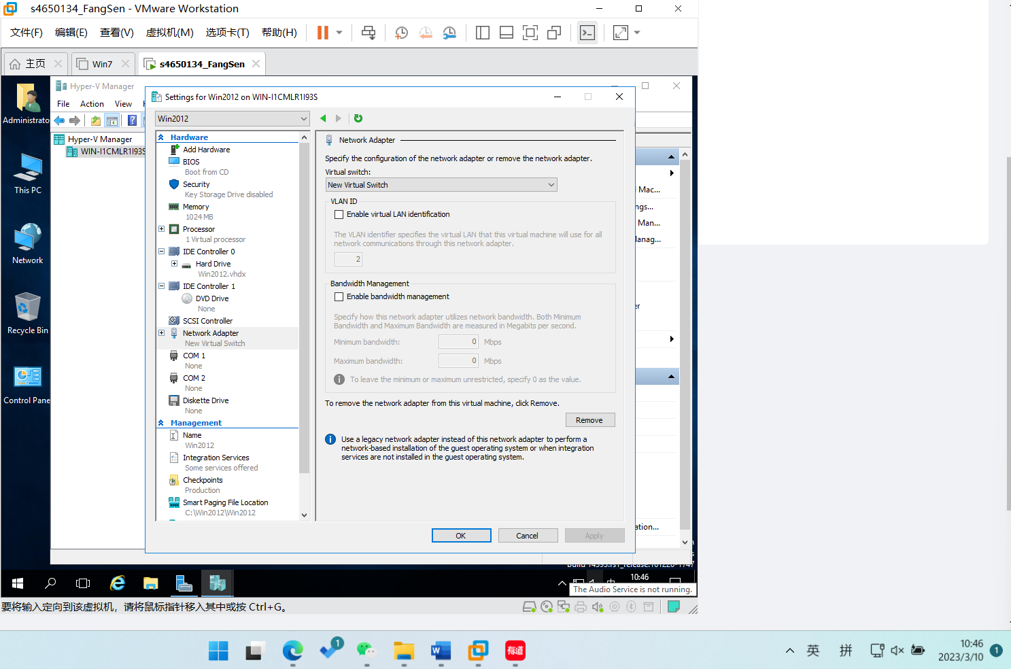

Figure



Figure

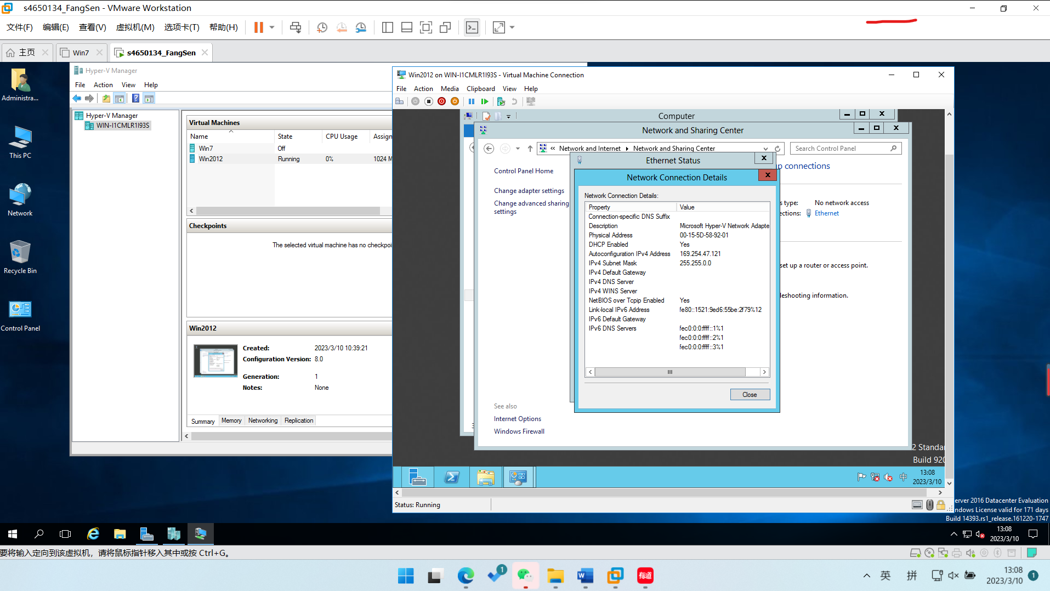

Figure

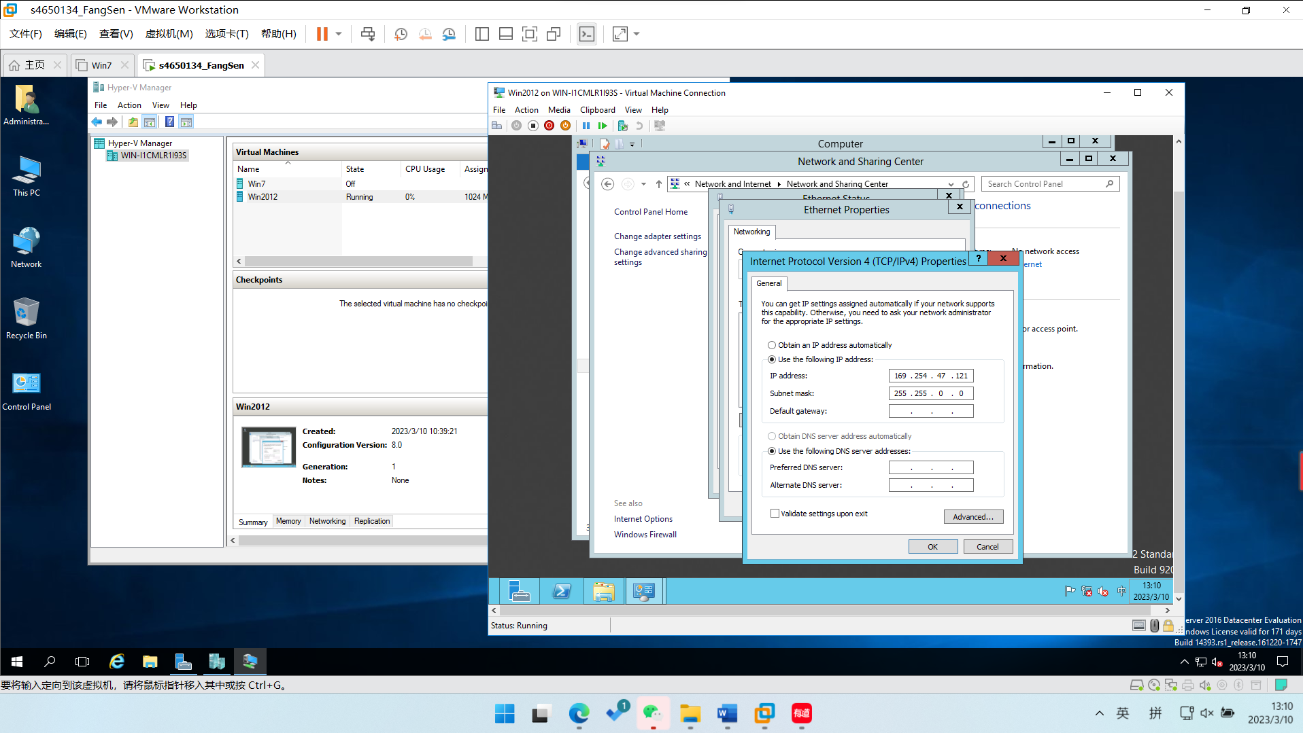

Figure

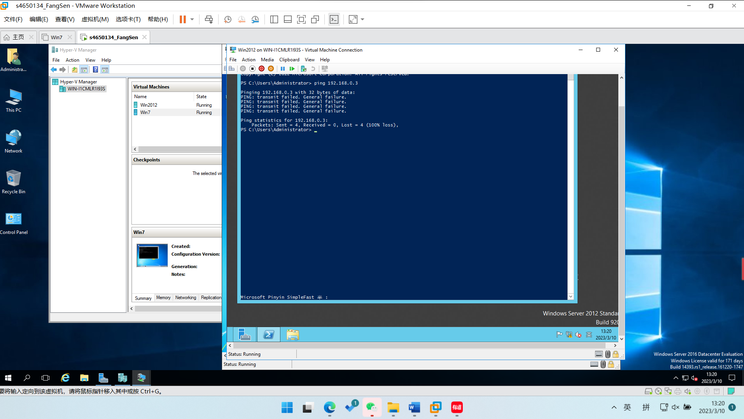

Figure

1. Scenario 2

In this scenario, allow all machines can communicate with one another. Create the appropriate network configuration according to the following figure.

Child

Parent

Host

Child

Upon completion, demonstrate to the lecturer that you have correctly configured each scenario by using the 'ping' command.

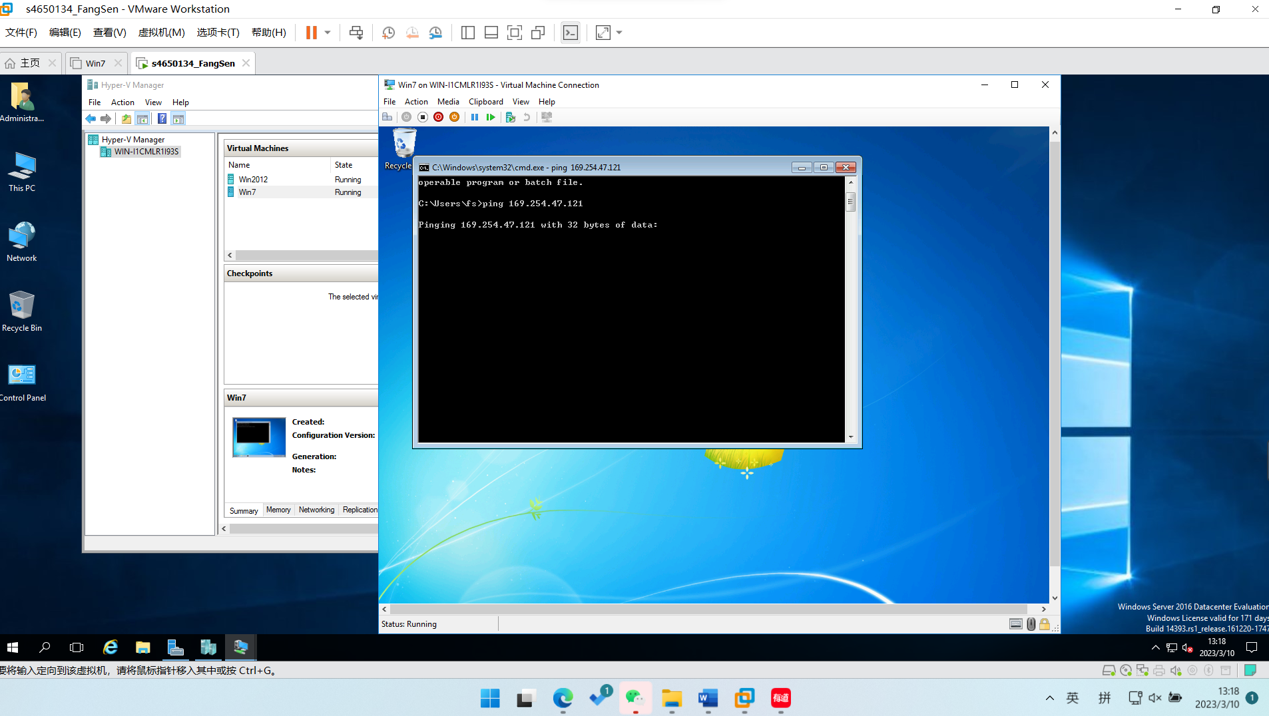

Figure

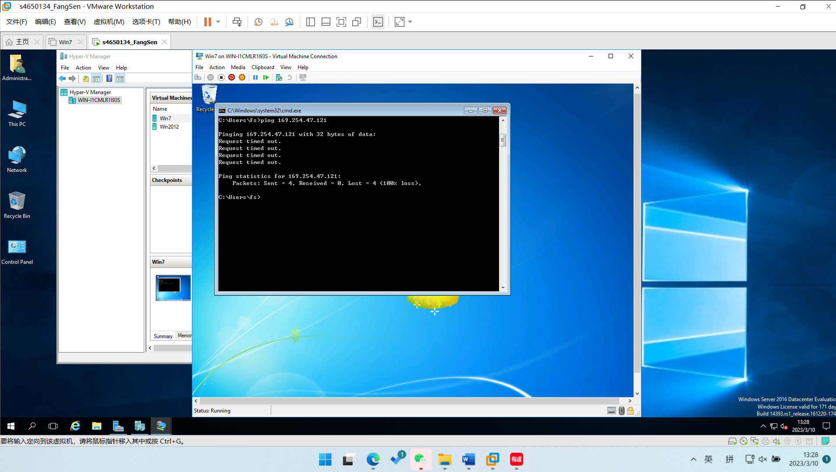

Figure